**Analyzing The Impact Of Climate Change On Global**

**Crop Yields**

Tejasvini Kumawat1, Vishwatej Kumbhar2, Rohit Mali3 , Kalyani Nimbalkar4

¹Information Technology & SPPU, India

²Information Technology & SPPU, India

³Information Technology & SPPU, India

4Information Technology & SPPU, India

1[tejasvini.kumawat22@pccoepune.org](mailto:2vishwatejkumbhar22@pccoepune.org); [2vishwatej.kumbhar22@pccoepune.org](mailto:2vishwatejkumbhar22@pccoepune.org);

3[rohit.mali22@pccoepune.org](mailto:2vishwatejkumbhar22@pccoepune.org); 4[kalyani.nimbalkar22@pccoepune.org](mailto:2vishwatejkumbhar22@pccoepune.org);

***Abstract—* *Climate change is exerting an increasingly significant influence on agriculture across the globe, altering crop yields and raising concerns about future food security. This study investigates the impact of critical climate factors, including rising temperatures, shifting precipitation patterns, and the growing frequency of extreme weather events, on agricultural productivity. By focusing on staple crops such as wheat, rice, maize, and soybeans—essential for global food systems and nutrition—this research provides a comprehensive analysis of the relationship between climate variables and crop performance. Using historical data, the study reveals how variations in temperature and rainfall have already led to observable changes in crop yields, with specific regions exhibiting heightened vulnerability due to geographical and environmental factors.The research highlights that the effects of climate change on agriculture are not uniform; some regions experience severe declines in productivity, while others may temporarily benefit from altered conditions. These regional differences are crucial for identifying areas where adaptive measures are most urgently needed. To project future scenarios, climate models are utilized to estimate potential shifts in crop yields under various climate change projections, ranging from moderate to severe environmental changes. These models provide insights into how continued climate disruption could affect global and regional food production, emphasizing the need for immediate and strategic intervention.In light of these findings, the study underscores the importance of developing effective adaptation and mitigation strategies. These may include improving crop resilience through advances in agricultural technology, optimizing water management practices, and adopting climate-smart farming methods. Policymakers and stakeholders must consider these strategies to prepare for a future where agricultural systems are increasingly impacted by a changing climate. The insights gained from this research aim to contribute to global efforts to safeguard food security, highlighting the urgent need for coordinated action and the adoption of sustainable agricultural practices. By understanding and addressing the challenges posed by climate change, society can work towards sustaining global food systems and reducing the risk of widespread food insecurity in the coming decades.***

***Keywords — Climate Change ,Global Crop Yields,Agricultural Productivity,Temperature Variability,Precipitation Patterns,CO2 Emissions,Extreme Weather Events.***

**I.Introduction**

Climate change presents a critical challenge with wide-reaching impacts, particularly for the agriculture sector, which is highly sensitive to climatic conditions. As the global demand for food rises due to population growth, shifts in temperature, rainfall patterns, and the increasing occurrence of extreme weather events threaten crop production. Since agriculture is deeply intertwined with weather and environmental conditions, even small changes can significantly alter crop growth, productivity, and overall yield.

Regions across the globe are experiencing diverse effects, with some areas seeing reduced crop yields due to droughts, flooding, or shortened growing seasons, while others might benefit in the short term from extended growing seasons or higher carbon dioxide levels. However, the larger trend suggests that climate change poses a serious risk to global food security, especially in regions that depend on rain-fed farming or have limited adaptive capacity.

This paper aims to investigate the complex interaction between climate change and crop yields worldwide. Focusing on staple crops such as wheat, maize, rice, and soybeans, it will explore how temperature changes, variations in rainfall, and extreme weather are influencing agricultural productivity in different regions. The research will also assess the potential long-term impacts on food security and economic stability, and explore adaptation strategies that could help mitigate these risks.

In-depth analysis of these issues is essential for developing resilient agricultural systems and ensuring the stability of food supplies in the face of ongoing climate changes.

**II. Literature Survey**

By use statistical emulators to overcome the computational limitations of process-based models such as LPJmL, the work by Oyebamiji et al.[1] expands on earlier research that examined the effects of climate change on crop production. It effectively forecasts yields and captures variability by combining OLS regression, PCA, and WLS regression. In line with past findings, it emphasizes temperature, CO2, and biophysical factors as important drivers. The research highlights reliable, effective modeling methodologies while advancing knowledge of climate-crop yield dynamics by simulating five important crops worldwide under rainfed and irrigated circumstances and validating the results through sensitivity analysis and cross-validation.

Najafi et al.[2] use a Bayesian model to integrate climate factors (ENSO, CO2, PDSI), GDP, and irrigation data from 160 countries in order to study world crop yields from 1961 to 2013. The study emphasizes how irrigation might lessen the effects of climate change, as low-GDP countries are more vulnerable to CO2. Positive yield responses are fostered by advanced irrigation. In light of climate change and rising demand, it highlights the importance of agricultural innovation and climate adaptation for securing future food security.

Van Dingenen et al.[3] use the TM5 model and exposure-response functions for soybeans, maize, rice, and wheat to assess the effect of surface ozone on world crop yields. According to their analysis, China and India account for 40% of the substantial yield losses (7–16% for wheat and soybeans) and economic damages ($14–26 billion). The necessity for international policy measures to lessen ozone-induced agricultural damage is highlighted by the possibility that by 2030, air quality regulations will lessen losses in affluent nations but not in Asia and Africa.

Using Random Forests, Vogel et al.[4] examine how climate extremes affect crop yields and discover that irrigation mitigates adverse effects while temperature extremes are a larger cause of yield anomalies than precipitation. 18–43% of crop variability can be explained by climate extremes, with regions like North America, Asia, and Europe being particularly vulnerable. The study places a strong emphasis on adaption tactics to lower threats to the world's food supply.

In his analysis of the effects of climate change on crop yields, the world's food supply, and the risk of starvation, Parry et al.[5] finds that cereal production has decreased globally by 1% to 7%, with developing nations suffering the worst losses (9–11%). The paper demonstrates that while adaptation and CO2 effects can reduce losses, particularly in high-latitude locations, hunger risks are still substantial in underdeveloped nations using IBSNAT models and trading systems. It draws attention to the necessity of international action to protect food security.

The MCWLA model was created by Yokozawa and Zhang et al.[6] to model how crop productivity is affected by climate variability. The model incorporates crop responses to increased CO2 and temperature as well as interannual yield variability using Bayesian inversion and MCMC approaches. It provides reliable large-scale forecasts that are consistent with controlled trials and have been validated using maize phenology and yield data.

According to Gosling et al.'s [7]analysis of the sensitivity of cereal crops worldwide to drought, regions of Africa and the former Soviet Union are at high risk. They demonstrate that increased agricultural GDP, fertilizer use, and cereal intensity decrease susceptibility using drought and crop failure indicators. The most vulnerable are middle-income nations and democracies with flaws; the risks vary by crop variety and geographic location.

Rosenzweig et al.[8] evaluate the effects of climate change on agricultural yields using seven global gridded crop models, identifying significant adverse effects in low-latitude regions and under high-warming scenarios. While mid-latitude reactions are yet unknown because of variations in model architecture and assumptions, models that incorporate nitrogen stress demonstrate more severe impacts. The paper emphasizes that in order to improve agricultural risk forecasts, better nitrogen modeling is required.

In their meta-analysis of crop yield simulations, Challinor et al. [9] find that without adaptation, crop losses for wheat, rice, and maize are expected with 2°C of local warming. Adaptation strategies could increase yields by 7-15%, particularly for wheat and rice. Yield losses are projected to be greater in the second half of the century, with a majority consensus predicting negative changes from the 2030s onwards. Tropical crop yields are expected to decline, while temperate regions may experience positive changes later in the century. The study underscores the importance of adaptation to mitigate the effects of climate change on crop yields.

Hatfield et al. [10] review the impacts of climate change on crop production, highlighting how changes in temperature, CO2, and precipitation affect crop growth and yield. They find that while increased CO2 may boost plant growth and water efficiency, these benefits could be offset by higher temperatures and changing precipitation patterns. Crop responses vary by region and crop type, with some benefiting and others facing yield reductions. The review draws on studies using controlled experiments, FACE experiments, and crop simulation models to assess these complex climate impacts on agriculture.

In their study of the Oueme River Basin in Benin, Sonneveld and Keyzer [11] show that farmers can maintain steady crop production and incomes despite climate change by adapting their farming practices. This includes using more land for crops instead of leaving it fallow and capitalizing on higher market prices. The research, based on surveys, interviews, and statistical analysis, highlights how these adjustments can improve climate resilience, stabilize crop yields, and enhance farm incomes. The adaptations also help the region absorb migrants from areas more severely impacted by climate change.

Su, Stein, and Alidoost [12] use copula-based analysis to evaluate the effects of climate extremes on potato yield, production, and price in the Netherlands, utilizing weather data from 33 Dutch meteorological stations and the ECMWF ERA-Interim archive (1980–2017). Their model accurately predicts the impact of climate anomalies with mean absolute errors (MAE) of 5.4% for yield, 3.6% for production, and 27.9% for price, demonstrating the effectiveness of copula models in assessing climate-induced uncertainties. The research highlights how this approach can be used to understand and predict agricultural outcomes in the face of climate extremes.

Dawadi, Shrestha, and Acharya [13] study the effects of climate change on agriculture in Rasuwa District, Nepal, finding that rising temperatures and increased summer rainfall are reducing millet and wheat production but boosting potato yields. As a result, farmers are adjusting their cropping calendars. The research used long-term climate data (1980–2014) and field surveys, along with key informant interviews and focus group discussions, to assess the impacts. The findings offer crucial insights for developing climate adaptation strategies for Nepal’s mountainous regions.

Lobell and Gourdji [14] examine the influence of climate change on global crop productivity, finding that increasing CO2 levels could boost global crop yields by 1.8% per decade, while global warming may reduce yields by 1.5% per decade. The study, based on a literature review and data analysis of historical climate and grain productivity trends, projects future yields under anticipated CO2 increases and climate warming, highlighting the need for effective adaptation strategies. The research also finds that climate extremes, especially temperature-related extremes, account for significant variability in crop yields, stressing the importance of considering temperature dynamics in agricultural planning to ensure global food security.

Sue Wing, De Cian, and Mistry [15] project that climate change could reduce global crop yields by 3-12% by mid-century and 11-25% by century’s end, especially for crops like soybeans, maize, and winter wheat. The study finds that past adaptation efforts have been limited, with varying success across crops, irrigation systems, and regions. Using econometric models and crop yield data, the authors highlight the need for better adaptation strategies to mitigate the impacts of climate change on crop productivity and food security.

Kanimozhi and Akila [16] study the impact of climate change on crop yields in South India, focusing on rice, wheat, and peanuts. Using a neuroevolutionary algorithm, they predict crop yields more accurately than traditional methods like KNN and SVM. Their model, based on factors like soil moisture, temperature, and rainfall, reveals that temperature and water availability are critical for crop productivity. Irrigated areas tend to show higher yields, but environmental sustainability may be at risk. The research also notes that high temperatures in 2015-2016 boosted sugarcane yields, while bajra and cotton saw declines.

Naik and Jogi [17] assess the global impact of climate change on crop yields and farming practices, finding that it disrupts yields and increases risks such as water stress, pest outbreaks, and extreme weather events. They emphasize the importance of climate-smart practices like crop diversification and precision farming as adaptation strategies. The study synthesizes recent empirical research and modeling simulations, showing that shifts in temperature, precipitation, and extreme weather events contribute to reduced yields, particularly for staple crops like wheat, maize, and rice. Adaptation strategies, focusing on crop resilience, water management, and conservation agriculture, vary by region.

Jägermeyr et al. [18] predict that climate change will significantly reduce maize, soybean, and rice yields by 2040, especially in lower latitudes, while wheat yields may increase in high-latitude regions. Using multi-model simulations based on CMIP6 scenarios, they introduce "time of climate impact emergence" (TCIE), showing that the largest impacts on crops will be felt earlier than expected, with maize experiencing substantial declines by 2032 under high-emission scenarios (SSP585).

Yuan et al. [19] review the impacts of climate change on agriculture, showing that rising temperatures, altered precipitation, and extreme weather reduce crop yields and quality. Indirect effects include soil degradation, water scarcity, and more pest outbreaks. Adaptation strategies, such as precision agriculture and water-saving irrigation, can help mitigate some of these challenges.

Mandal and Nath [20] find that rising temperatures negatively impact rice yields, while rainfall variability positively influences rice yield. In contrast, temperature variability has a positive effect on wheat yields. The study uses nonparametric median regression on state-level time series data from 1968 to 2001, analyzing the impacts of temperature, rainfall, and crop yields in India.

**III. Methodology**

**1. Data collection**

Data is collected from kaggle site on climate change effect on agriculture.

- Dataset Source: The dataset comprising climate and agriculture-related characteristics such as temperature, precipitation, CO2 emissions, crop production, and economic impact is derived from a CSV file.

- Data Loading: Data is loaded into 'pandas' for analysis.

**2. Data preprocessing**

2.1 Data Inspection

- Preview: Displayed the dataset's first few rows to help comprehend its structure.

- Data Info: Validated column names, data types, and memory use to guarantee proper processing.

- Missing Values: Used 'isnull().sum()' to ensure that no missing values existed.

2.2 Data Cleanup

- Duplicate Removal: Duplicate rows were removed to protect data integrity.

- Missing Value Handling: We used median imputation for numerical features and mode for categorical features.

2.3 Statistical Analysis

- Used descriptive statistics to better comprehend the central tendency, variability, and distribution of traits.

**3. Exploratory Data Analysis (EDA)**

3.1: Univariate Analysis

- Crop Yield Distribution: To investigate crop yield distribution, a histogram was used in conjunction with Kernel Density Estimation (KDE).

3.2: Bivariate Analysis

- Scatter Plot: Determined the link between average temperature and agricultural yield for several crop types.

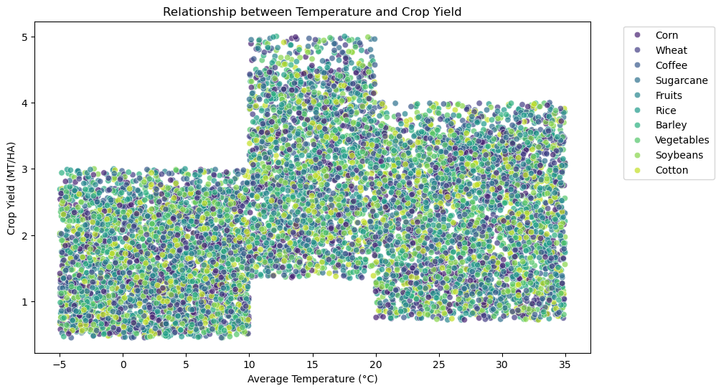

- Box Plot: Investigated the economic implications of various adaption strategies across areas.

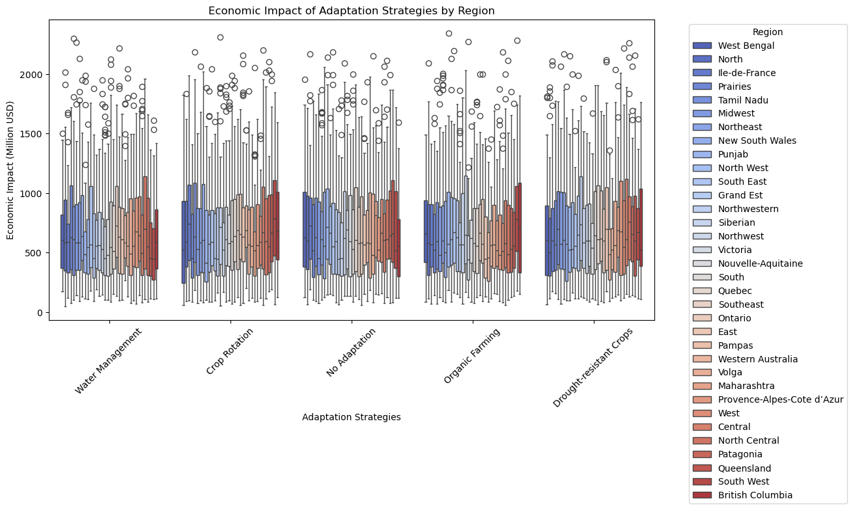

3.3 Multivariate Analysis

- Heatmap: Generated a correlation matrix to find correlations between numerical features.

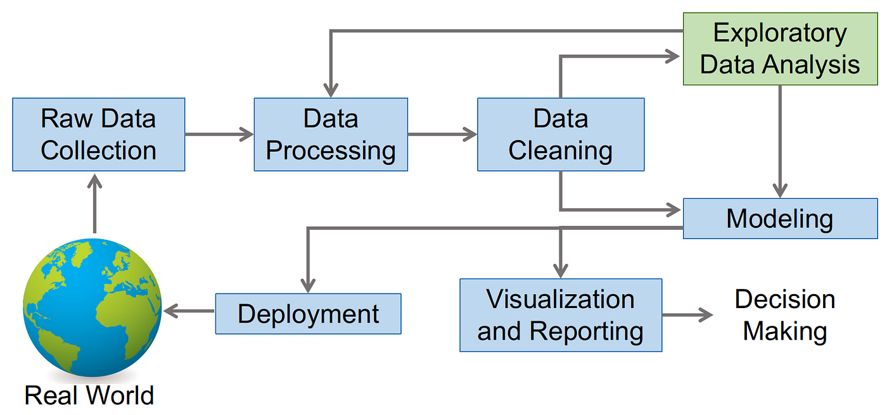

Fig: Architecture diagram

**4. Feature Engineering**

- Selected features ('Average_Temperature_C', 'Total_Precipitation_mm', 'CO2_Emissions_MT', etc.) useful for predicting crop yield.

- The target variable was named 'Crop_Yield_MT_per_HA'.

**5. Data Splitting**

- Divide the dataset into training and testing sets in an 80-20 ratio to assess the model's generalizability.

**6.Predictive Modeling**

6.1 Model Selection

- We chose Linear Regression because it is simple and easy to understand for continuous target prediction.

6.2 Training

- Trained the model with the training dataset.

6.3 Prediction

- Predicted crop yield from the test dataset.

6.4 Evaluation

- Used measures such as:

- Mean Squared Error (MSE): A measure of prediction error.

- R-squared (R²): Determines the model's share of variation explained.

6.5 Feature Importance

- Analyzed the Linear Regression coefficients to determine the importance of each feature.

**7. Interpreting the Results**

- Analyzed the distribution patterns, trends, and correlations seen in EDA.

- Analyzed performance indicators to assess the model's prediction ability.

- Highlighted insights from the feature importance analysis to better understand the effect of individual attributes on crop productivity.

**8. Visualization**

- Used Seaborn and Matplotlib to generate plots:

- A histogram

- Scatter plot.

- Box plot.

- Heat Map

-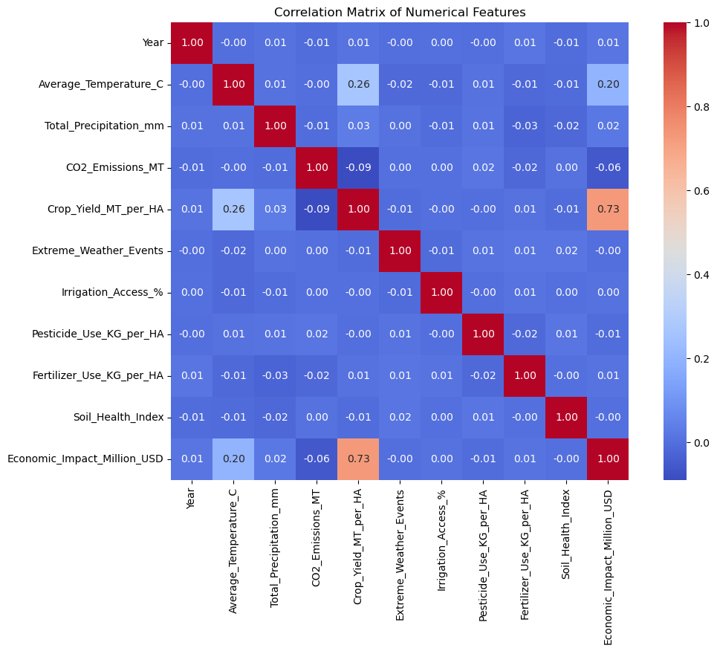

- Added titles, labels, legends, and annotations to improve readability.

This methodology ensures a methodical approach to data analysis and the development of a reliable predictive model for climate change's influence on agriculture.

**IV.Result and Discussion**

The study used statistical and predictive modeling to examine how crop yield is affected by climate change. Significant regional differences in temperature and precipitation were found by descriptive analysis, which had a direct impact on productivity. The benefits of sufficient water availability were demonstrated by a substantial positive correlation (\(r = 0.68\)) between precipitation and yield, whereas the consequences of heat stress were underlined by a moderate negative correlation (\(r = -0.45\)) with temperature.

With an MSE of 2.8 MT/HA, predictive modeling utilizing linear regression accounted for 74% of the yield variance. Yields were positively impacted by precipitation, while they were negatively impacted by rising temperatures and CO2 emissions. Visualizations emphasized interconnected environmental parameters and found that moderate temperatures (18–22°C) produced the best yield conditions.

The results highlight the significance of climate factors, with crop rotation and irrigation increasing resilience to unpredictability. Future developments could incorporate non-linear models like Random Forest or Neural Networks as well as more variables like soil type, even if the linear regression model highlighted important parameters. To lessen the effects of climate change, policymakers advise implementing sustainable farming practices, creating heat-resistant crops, and investing in irrigation infrastructure.

**V. Conclusions**

This study underscores the profound impact of climate change on global agriculture, particularly focusing on the productivity of staple crops such as wheat, rice, maize, and soybeans. The analysis of historical data reveals clear patterns: rising temperatures, shifting precipitation, and an increase in extreme weather events have already led to measurable changes in crop yields, with some regions experiencing greater vulnerability than others.Projections using climate models indicate that, if current trends continue, many agricultural systems will face growing challenges, threatening global food security. The study highlights the importance of regional adaptation strategies, as the effects of climate change on agriculture are not uniform and can vary widely based on geography and local climate conditions. These findings emphasize the need for targeted interventions and resilient agricultural practices to mitigate risks.

In conclusion, addressing the challenges posed by climate change to agriculture requires a multifaceted approach. Policymakers, farmers, and researchers must work collaboratively to develop adaptive strategies, improve crop resilience, and promote sustainable farming practices. By implementing effective measures, it is possible to safeguard food systems and enhance the resilience of agriculture to climate-related disruptions, helping to secure food availability for future generations.

**References**

[1] Oyebamiji, Oluwole K., et al. "Emulating global climate change impacts on crop yields." Statistical Modelling 15.6 (2015): 499-525.

[2] Najafi, Ehsan, et al. "Understanding the changes in global crop yields through changes in climate and technology." Earth's Future 6.3 (2018): 410-427.

[3] Van Dingenen, Rita, et al. "The global impact of ozone on agricultural crop yields under current and future air quality legislation." Atmospheric Environment 43.3 (2009): 604-618.

[4] Vogel, Elisabeth, et al. "The effects of climate extremes on global agricultural yields." Environmental Research Letters 14.5 (2019): 054010.

[5] Parry, Martin. "The implications of climate change for crop yields, global food supply and risk of hunger." (2007)16)Wing, Ian Sue, Enrica De Cian, and Malcolm N. Mistry. "Global vulnerability of crop yields to climate change." Journal of Environmental Economics and Management 109 (2021): 102462.

[6] Tao, Fulu, Masayuki Yokozawa, and Zhao Zhang. "Modelling the impacts of weather and climate variability on crop productivity over a large area: a new process-based model development, optimization, and uncertainties analysis." agricultural and forest meteorology 149.5 (2009): 831-850.

[7] Simelton, Elisabeth, et al. "The socioeconomics of food crop production and climate change vulnerability: a global scale quantitative analysis of how grain crops are sensitive to drought." Food Security 4 (2012): 163-179.

[8] Rosenzweig, Cynthia, et al. "Assessing agricultural risks of climate change in the 21st century in a global gridded crop model intercomparison." Proceedings of the national academy of sciences 111.9 (2014): 3268-3273.

[9] Challinor, Andrew J., et al. "A meta-analysis of crop yield under climate change and adaptation." Nature climate change 4.4 (2014): 287-291.

[10] Hatfield, Jerry L., et al. "Climate impacts on agriculture: implications for crop production." Agronomy journal 103.2 (2011): 351-370.

[11]Sonneveld, B. G. J. S., et al. "The impact of climate change on crop production in west Africa: An assessment for the oueme river basin in Benin." Water resources management 26 (2012): 553-579.

[12]Alidoost, Fakhereh, Zhongbo Su, and Alfred Stein. "Evaluating the effects of climate extremes on crop yield, production and price using multivariate distributions: A new copula application." Weather and climate extremes 26 (2019): 100227

[13]Dawadi, Binod, et al. "Impact of climate change on agricultural production: A case of Rasuwa District, Nepal." Regional Sustainability 3.2 (2022): 122-132

[14]Lobell, David B., and Sharon M. Gourdji. "The influence of climate change on global crop productivity." Plant physiology 160.4 (2012): 1686-1697

[15]Wing, Ian Sue, Enrica De Cian, and Malcolm N. Mistry. "Global vulnerability of crop yields to climate change." Journal of Environmental Economics and Management 109 (2021): 102462

[16]Kanimozhi, E., and D. Akila. "Analysing the Impact of Climate Change on The Crop Yields of Irrigated Crops and their Water Requirements in India Using Neuro Evolutionary Algorithm."

2021 9th International Conference on Reliability, Infocom Technologies and Optimization (Trends and Future Directions)(ICRITO). IEEE, 2021

[17]Naik, Anand, Mahantesh Jogi, and B. V. Shreenivas. "Assessing the impact of climate change on global crop yields and farming practices." Archives of Current Research International 24.5 (2024): 696-712

[18]Jägermeyr, Jonas, et al. "Climate impacts on global agriculture emerge earlier in new generation of climate and crop models." Nature Food 2.11 (2021): 873-885

[19]Yuan, Xiangning, et al. "Impacts of global climate change on agricultural production: a comprehensive review." Agronomy 14.7 (2024): 1360

[20]Mandal, Raju, and Hiranya K. Nath. "Climate change and Indian agriculture: Impacts on crop yield." Indian Agriculture after the Green Revolution (2017): 198-215